

# Sesame Workshop & LEGO Foundation Initiative,

# Eastern Cape, South Africa

# Evaluation Findings Executive Summary

15 March 2018

**Kelello, in collaboration with   
Centre for Education Practice Research (CEPR), University of Johannesburg**

Shafika Isaacs,   
Garth Spencer Smith,

Nicky Roberts

[nicky@kelello.org](mailto:nicky@kelello.org)

[nroberts@uj.ac.za](mailto:nroberts@uj.ac.za)



This executive summary forms part of a larger evaluation research report which was commissioned by Sesame Workshop on behalf of the Lego Foundation who funded the Play Well and Be Happy Programme.

Date of publication: 30 April 2018

This work is registered with Creative Commons https://creativecommons.org/licenses/ as follows: CC licensing agreement here with logos

**Suggested citation:**

Isaacs S, Roberts N and Spencer-Smith G (2018): *Play Well and Be Happy. Evaluation Research Brief. A Sesame Workshop and Lego Foundation Initiative*, Kelello and University of Johannesburg, Johannesburg

**Enquiries to:**

Nicky Roberts

(c) +27 71 525 8389

Email: [nicky@kelello.org](mailto:nicky@kelello.org)

 

# Introduction

Play Well & Be Happy (PW&BH) is a play-based multi-media capacity-building programme that targets Early Childhood Development (ECD) practitioners and educators in Grade R and pre-primary classrooms of children aged 5 to 7 years, across three districts (East London, Port Elizabeth and Lusikisiki) in the Eastern Cape. The programme is a partnership between the LEGO Foundation, Sesame Workshop (incorporating Takalani Sesame), the Eastern Cape Department of Education (ECDOE), and the Buffalo City Metropolita Municipality (BCMM).

This summary consolidates the findings of the PW&BH evaluation over four successive phases.

The evaluation was conducted by Kelello Consulting in collaboration with the University of Johannesburg’s (UJ) Centre for Education Practice Research (CEPR). The evaluation process spanned a 14-month period from January 2017 to March 2018 and included

* an evaluation plan published in April 2017;
* an evaluation report on each of the four implementation phases between April 2017 and January 2018; and
* this final evaluation report excutive summary (March 2018).

# 

# Purpose of Evaluation

The purpose of the evaluation was to provide an independent yet engaged perspective on the design, implementation and outcomes of the PW&BH over four successive implementation phases. It also served to promote collective learning of all stakeholders and the continuous improvement of the PW&BH in ways that could sustain value to the larger Grade R education system in the Eastern Cape.

# Participants and Context

|  |  |
| --- | --- |
| Across all four phases, the average practitioner was female, isiXhosa-speaking, mostly in their forties, taught Grade R children, had less than 10 years’ experience as a teaching practitioner, and had a Level 4 ECD qualification. | Figure 1: PW&BH practitioners |

The contexts of each of the four PW&BH phases had their own unique peculiarities and varying degrees of social, economic, educational and infrastructural challenges. Phases 1, 2 and 4 were based in urban settings compared to Phase 3’s deep rural context of Lusikisiki where conditions were more challenging.

##### Eight out of fourteen**[[1]](#footnote-1)** sites visited had inadequate toilets, ten had insufficient outside playing areas and seven had inadequate classroom sizes. Problem Statement

The main problem that the PW&BH sought to address was the lack of strategies and skills which would allow Grade R practitioners and educators to integrate play in their practice in order to improve the cognitive, social and emotional skills of children in their classrooms. Capacity-building programmes of these practitioners faced a number of critical barriers, which included:

* Low status of Grade R within the Foundation Phase (Grade R to Grade 3);
* Poor working conditions & job insecurity of Grade R practitioners;
* Lack of formal qualifications among the majority of Grade R practitioners;
* Corporal punishment in primary schools reported by practitioners;
* Overcrowded classrooms;
* School management’s lack of awareness & acknowledgement of importance of Grade R practitioners; and
* No formal assessment of practitioner knowledge.

# Theory of Change

The following theory of change served to guide the programme during Phases 2, 3 and 4 following revisions to the original draft developed during Phase One.

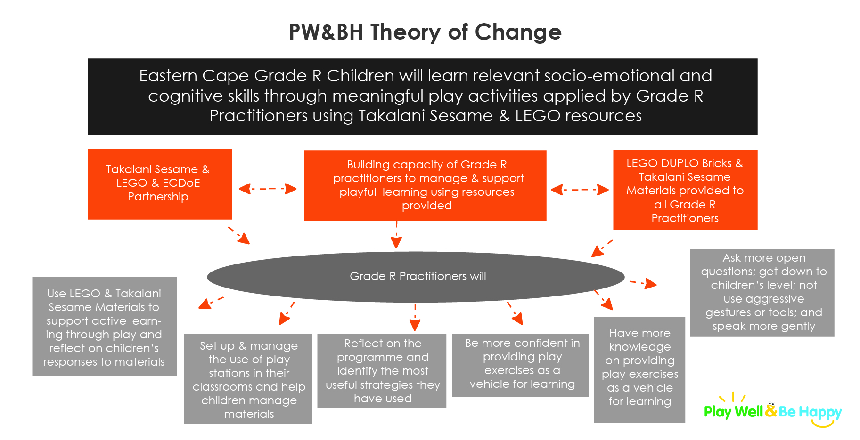

Figure 2: Revised theory of change, used from Phase 2

# Programme Design & Implementation

The PW&BH was designed to be implemented over four phases in order to iterate and modify the programme based on learnings from the evaluation of each successive phase. PW&BH had widespread reach across the Eastern Cape’s Grade R and pre-primary school system.

##### PW&BH trained

##### 966 Grade R and pre-primary practitioners and principals which included

##### 81 lead practitioners and facilitators;

##### in 23 training sessions between 28 February and 30 November 2017.

##### Across three districts in the Eastern Cape, it reached

##### approximately 30 000 children aged 5 to 7 years

##### And delivered PW&BH kits (see the figure below) were also provided to 966 classrooms.

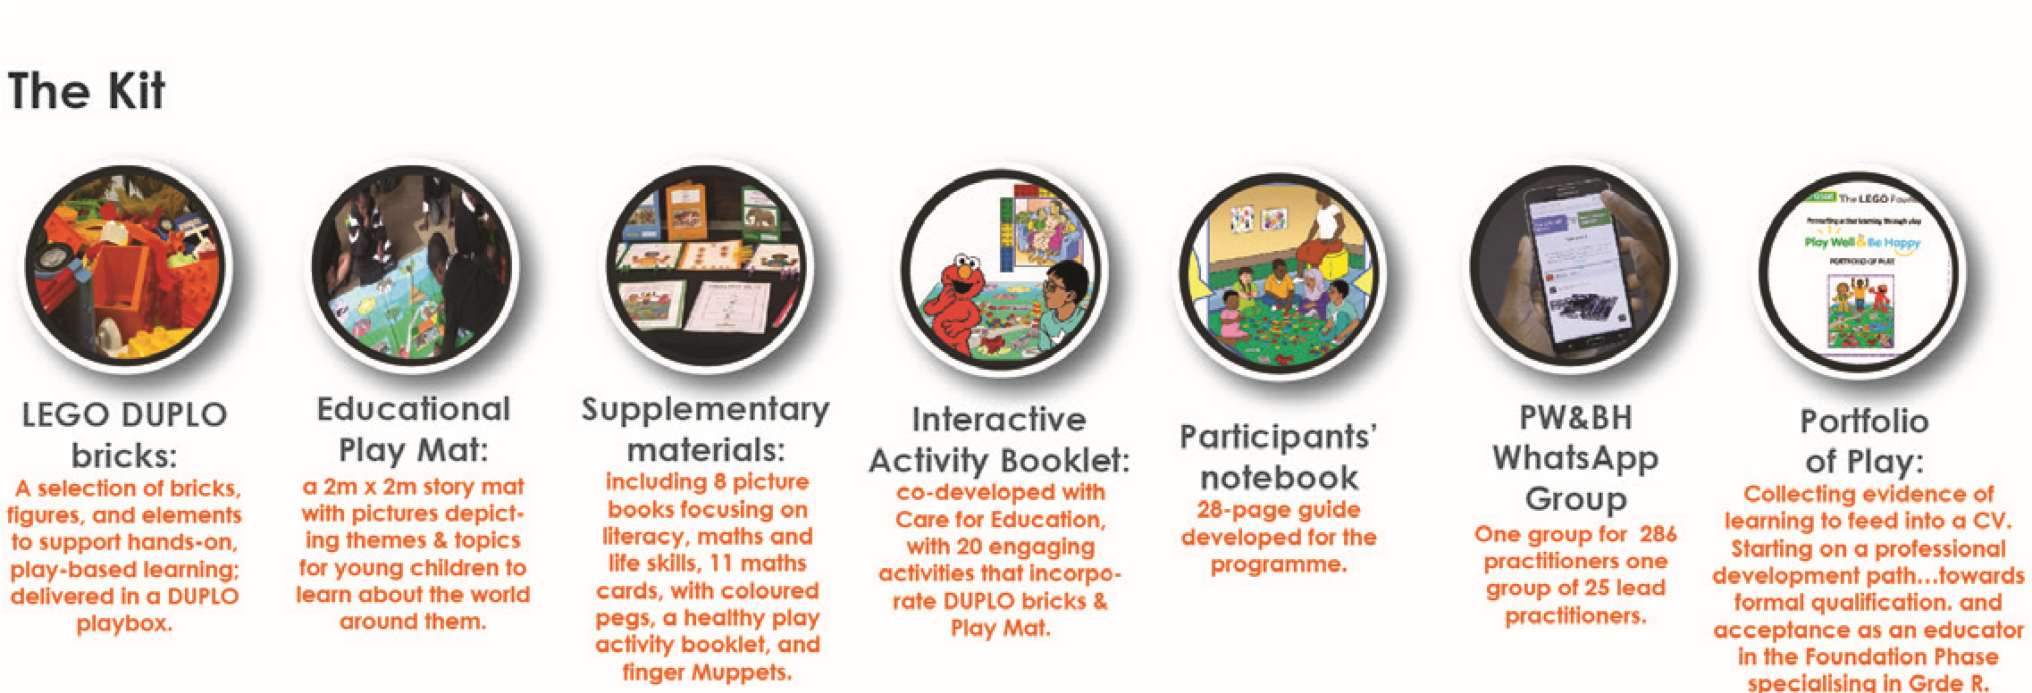

Figure 3: PW&BH Kit

Phases 1, 2 and 3 involved Grade R practitioners in formal primary schools registered with the ECDOE, while Phase 4 focused on Grade R and pre-primary practitioners and principals in informal, privately-owned ECD Centres registered with the Department of Social Development (DSD).

|  |  |
| --- | --- |
| The programme included advocacy and awareness-raising workshops among parents, principals, circuit managers and school heads of departments (HODs). The latter created institutional buy-in and support for the objectives of the PW&BH, particularly in Phases 2, 3 and 4. Inline images 3  Figure 4: Advocacy workshop with circuit managers | Figure 5: Advocacy workshop with parents |

The programme also had strong buy-in and support from the **ECDOE political leadership and senior management**, which grew with each successive PW&BH phase.

The five-week training programme was delivered over four phases in three districts as a South African Council of Educators **(SACE)-registered one-plus-four course** where practitioners were trained for one day, practiced what they learned using the PW&BH kits over the subsequent four school days; and provided feedback on their experience when they reconvened.

|  |  |
| --- | --- |
| Figure 6: Example of page from the POP | Because the course was designed as an initial entry point to encourage practitioners to pursue further professional development, the **Portfolio of Play (POP)** served as self-evaluation that did not incorporate individual feedback to participants nor was it linked to a play-based competency assessment framework. |

PW&BH involved **25 to 26 lead practitioners** in Phases 1, 2 and 3 and five facilitators from NGOs in Phase 4 who provided peer support to participants throughought the five-week training programme.

**WhatsApp groups** in each phase served to build community among practitioners.

**Delivering a mass-based** training programme of 300 participants per day across Phases 1, 2 and 3 proved to be very challenging for a small core team. The shift to smaller groups of 30 participants per day in Phase 4 proved to be more manageable.

Phase 4 **integrated the water, sanitation and hygiene (WASH**) programme in PW&BH. This involved training practitioners to include good hygiene practice in their lessons and a WASH play station when they divide the class into PW&BH play stations.

# Research Design

The PW&BH evalution adopted a design-based research approach which involved continuous improvement in evaluation design and implementation in subsequent phases based on lessons from previous phases.

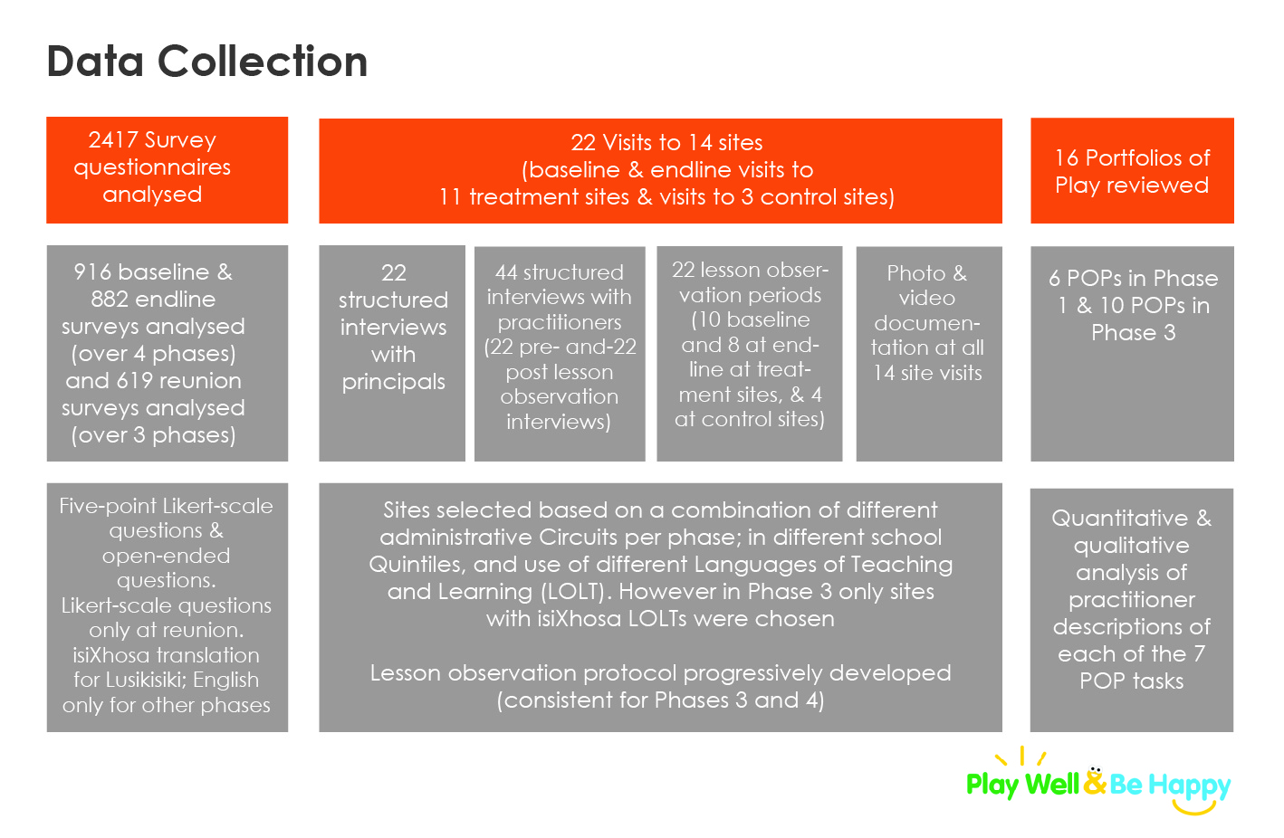

Figure 7: Data collection methods used in evaluation

# 

# Programme outcomes

|  |  |
| --- | --- |
| Outcome 1: Principals/practitioners are more confident in providing play exercises as a vehicle for learning. | |
| **Finding 1:** In all four phases there was a significant positive shift in the practitioner-reported level of confidence with providing play experiences (moderate to large effect sizes) | |
| **Finding 2:**  Lesson observations of five practitioners at both baseline and endline showed that   * **2 displayed positive change in confidence;** * **2 showed no change, and** * **1 reduced slightly in confidence.** | Figure 8: Practitioners developing confidence with play |

|  |  |
| --- | --- |
| Outcome 2: Practitioners/principals have more knowledge about providing play exercises as a vehicle for learning | |
| **Finding 3:**  Across all phases, participants reflected **a basic understanding of learning through play** in their survey responses. Lusikisiki practitioners showed **a significant improvement in understanding from baseline to endline** (with moderate effect size) but Buffalo City practitioners showed a significant decrease in understanding (with a moderate effect size).  . | Figure 9: Practitioners demonstrating their understanding of play |
| **Finding 4:** Participants showed, in their endline survey responses, **an intermediate level of understanding of what children learn through play** even though they reflected no change from baseline to endline in the quality of their written responses in Lusikisiki and Buffalo City**.** | |
| **Finding 5.** Participants in East London, PE and Lusikisiki showed a significant **positive shift in opinion** from baseline to endline about the **benefits of play to children, with small effect sizes.** However, in Buffalo City, there were significant negative shifts in opinion, with moderate effect size. | C:\Users\Public\Documents\Sonja's Files(34)\Z KELELLO\Consulting 2017\September 2017\RESEARCH\Siwali school\Snapshots Siwali\Snapshot 15 (2017-10-10 03-09 PM).png  Figure 10: Practioners had positive shifts in opinion on the benefits of play for children |

|  |  |  |
| --- | --- | --- |
| Outcome 3: Practitioners/principals use LEGO & Takalani Sesame Materials to support active learning through play | | |
| **Finding 6:** Survey results show a high level of agreement among practitioners that ‘*Lego and Takalani materials make it easier to support play’*. | Figure 11: Use of PW&BH materials in class | |
| **Finding 7:** Observed lessons delivered by five practitioners in East London, Lusikisiki and Buffalo City at baseline and endline showed **uneven use of PW&BH materials. In three of the five cases there was good to excellent improvement in use of PW&BH materials**; in one case, there was no change; and in another case there was a negative change from a low score to an even lower score. Here it is important to bear in mind that practitioners at baseline would not have been trained to use the PW&BH materials as yet. | | |
| Outcome 4: Practitioners/principals set up and manage the use of play stations in their classrooms | | |
| **Finding 8:** Survey findings showed that **the majority of practitioners exhibited a basic understanding of how to set up their classroom** to facilitate learning through play. | | Figure 12: Use of play stations in class |
| **Finding 9:** Survey findings also showed that across all four locations, the majority of practitioners said that their children know how to be organised into groups.  Table 1: Practitioner views on children and play stations   |  |  |  |  |  | | --- | --- | --- | --- | --- | | **Statement** | **% Agreeing or strongly agreeing** | | | | | **EL** | **PE** | **Lusiki.** | **BCMM** | | The children in my class now know how to be organised into groups of 5-6 so they can all be playing | 87.7% | 78,3% | 81.9% | 91.7% | | | |

|  |  |  |
| --- | --- | --- |
| Outcome 5: Practitioners ask more open questions; use a calm tone of voice; listen to children; bend down to children’s height; and do not use aggressive gestures or tools. | | |
| **Finding 10:** In their responses to Likert-scale survey questions, participants either strongly agreed or agreed that **after training they asked more open questions; spoke more calmly; and bent down to children’s level** when they engaged with children. | | |
| **Finding 11:** Three out of five practitioners observed at baseline and endline revealed **improvement in a combination of asking open questions, getting down to the children’s level, using a calm tone of voice, and using positive, non-aggressive words and actions**. However, two showed a negative change on their interaction with children. | **C:\Users\User\Documents\BCMM Endline\videos and photos\DSC_0229.JPG**  Figure 13: Practitioner bending down to children’s level | |
| Outcome 6: Children spend more time in enjoyable, playful learning activities in class each day | | |
| **Finding 12:**  Survey findings showed that most participants strongly agreed or agreed that, after training, the children in their classes   * spent more time in enjoyable playful learning activities, * talk more to the practitioner and each other, and * manage their own play better. | | |
| **Finding 13:** **Four out of five practitioners** (one in East London, three in Lusikisiki and one in Buffalo City) observed at both base- and endline, **showed good improvement in their scores on the amount of time children spent in enjoyable learning through play.** They **communicated with the practitioner and with each other, working well with and respecting each other, and managed their own play.** In one case there was little change from baseline to endline. | Figure 14: Children spending time in playful learning | |
| **Finding 14: Lesson observations** of seven practitioners showed, however, **that children managed their own play to a limited extent** with five of the seven receiving a score of 1 (‘to a limited extent’) at endline. | Figure 15: Children managed their own play to a limited extent | |
| Outcome 7: Reflect on the programme and identify the most useful strategies they have used | | |
| **Finding 15:** For principals and practitioners, **the top benefits for children were that PW&BH**   * provided new materials; * benefited children educationally; and * made lessons more exciting; and taught children how to respect and share with each other. | | |
| **Finding 16:** The **top reported benefits of PW&BH for the principal/practitioners** included:   * Receiving quality resources; * Learning how to run and manage play stations; and * Learning new ideas to use with children. | | Figure 16: Practitioners learning new ideas |
| **Finding 17:** The top challenges to implementing learning through play included   * Lack of space; * Too many children; * Poor learner behaviour and lack of co-operation; and * Children not wanting to share. | | Figure 17: Lack of space in classrooms |
| **Finding 18:** The top reported challenges to implementing learning through play included: lack of space; too many children; and poor learner behaviour / lack of cooperation. | | |
| **Finding 19:** Participants requested more training on classroom management and on working with children with barriers to learning. | | |
| **Finding 20:** Participants suggested that PW&BH could be improved by supplying more resources, but each location had a largely different set of recommendations. | | |

#### 

# Lessons and recommendations

## Programme concept and implementation

### Course design, content and instructional materials

|  |  |
| --- | --- |
| **Lessons** | **Recommendations** |
| The PW&BH course was not a formal competency-based professional development course but an initial non-formal entry point into a more formalized continuous professional development pathway. | Develop a play-based competency assessment framework for PW&BH that can draw on the coding rubric and the lesson observation protocol used by evaluators.  Show how completion of the PW&BH course can be a stepping stone to ongoing continuous professional development by demonstrating how the process and pathway towards formal qualifications have the potential to lead to improved livelihoods.  Commission an expert review of the training materials within the context of an assessment framework. |
| The course did not include a formal play-based competency assessment framework |
| The POP did not include individual feedback to the practitioners and was disconnected from evaluation questions | Redesign the POP to include:   * Consideration of the open questions in the survey * written, personalized feedback to each of the participants on the way they have applied learning through play and what they can do to improve their practice. |
| Practitioners demonstrated the biggest weakness in understanding the practice of applying different play strategies, asking open questions and enabling children to manage their own play. | Provide more examples and clarity on the meaning of different play strategies and the appropriate conditions when and how to apply each of them. |
| Take into account the recommendations by the practitioners, which include timing the training better and considering children with special needs. |

### Principal training

|  |  |
| --- | --- |
| The training programme included a number of principals especially in Phase 4, but it was not adapted to accommodate principal training and a cascade model where the principal trains the practitioner afterwards. | Develop dedicated training programme for principals, circuit managers and HODs. |
| Develop a theory of change that articulates clear outcomes for principals, practitoners and children. |
| Clear communication among principals and practitioners about the importance of staying the course over the five weeks is important in view of the experience with one practitioner only attending one of the five training sessions. |

### Mass delivery vs smaller, deeper interventions

|  |  |
| --- | --- |
| **Lessons** | **Recommendations** |
| The programme was too large-scale and widespread for the small core implementation team to deliver effectively, consistently and sustainably. | Go smaller through the training of small groups; deeper by making better use of facilitators, lead practitioners as peer coaches. |

### Evaluation research

|  |  |
| --- | --- |
| **Lessons** | **Recommendations** |
| Implementation of the different PW&BH phases were not spaced out enough to accommodate lessons that emerged from previous phases, thereby compromising the design-based approach of the evaluation and the emergent design of the programme. | Provide sufficient time for evaluation feedback to feed into improved programme implementation. |
| A number of disconnects existed between the evaluation design and instrumentation and the programme design and implementation. This emerged due to the limited involvement of the core team in the evaluation design. | Ensure stronger involvement of core implementation team in evuation design instruments and coding protocols. |
| Doing more and longer site visits provided rich descriptions of the practice of play and complemented the self-reporting survey questionnaires. | Invest in more site visits in the way they were designed in Phases 3 and 4. |
| The use and analysis of the WhatsApp groups were not included in the evaluation design | Include an analysis of the content of the WhatsApp groups in future similar evaluations. |
| A tighter lesson observation protocol was developed in the Phase 4 compared to Phase 3 and other phases, although this was not developed in collaboration with the core implementation team. | Develop an improved lesson observation protocol in consultation with the core implementation team. |

# Conclusion and Next Steps

The original research question that guided the evaluation of the PW&BH programme was:

*How did the ECD practitioners respond to the PW&BH capacity-building programme and support materials with particular reference to perception of value?*

The evaluation applied a basic three-level learning-through-play catalogue to reflect on the attainment of PW&BH outcomes for the practitioners. They included:

Level 1: Changes in practitioner attitudes and perceptions;

Level 2: Changes in practitioner knowledge; and

Level 3: Changes in practitioner practice as evident in the classroom.

All of the abve was considered in relation to the profile of participants and their challenging contexts of ECD implementation.

The Play Well & Be Happy programme has met and exceeded its implementation targets.

A four-phase design-based implementation has allowed for iterative improvements to the design over four cycles. The practitioners were overwhelmingly positive about their experiences of the programme. This was also evident from their very high attendance and completion rates for the Portfolios of Play across all four phases.

There was clear evidence of shifts in relation to practitioners’ attitudes, beliefs and confidence about play which aligns with Level 1 aspects of the programme outcomes. There was also some evidence of positive shifts in Level 2: changes in practitioner knowledge of play, although this was not always evident across all of the learning outcomes in the practitioners written responses to questions. Finally, while there was some evidence relating to Level 3: changes in practitioner practice of play as evident in the classroom, amongst the 14 case study practitioners. There was evidence across all four phases that practitioners showed a a number of positive applications of play thorugh the use of PW&BH materials and the organisation of play stations, however there remained much teacher-centred talk; very little to no use of open questions with children nor encouraging children to collaborate with one another and manage their own play. It is clear that the practitioners require more support with classroom-based coaching or feedback to see the hoped-for long-term outcome of ‘*Eastern Cape Grade R children learning relevant socio-emotional and cognitive skills through meaningful play activities applied by Grade R practitioners using Takalani Sesame and LEGO resources’*. The PW&BH programme was a necessary but not sufficient intervention which has helped the Eastern Cape Department of Education to place practitioners on a path towards more confidence and knowledge, better qualifications and improved practice.

Communication about the successes and lessons from the PW&BH to the wider public, stakeholders and the research and evaluation community has been very limited to date. It is recommended that an important next step would be for a communication plan to be developed so that the the research findings and lessons can be shared among stakeholders across the ECD system in South Africa.

1. Fourteen sites were visited in total including 3 sites in PE and 1 additional site in Buffalo City. Of these 10 case studies were written up. [↑](#footnote-ref-1)